**Docker Task-2**

1. **Create a tomcat container on 8080 and deploy sample application in tomcat.**
2. **Create volume and deploy tomcat container on port 8081.**
3. **Limit the nginx container to 500 MB.**
4. **Create a sample docker file using below instructions.**
   1. **Base module as amazonlinux:latest**
   2. **Maintainer you name**
   3. **Install nginx**
   4. **COPY one index.html file to image**
   5. **Expose on port 80**
   6. **Command to start the nginx container**
5. **Push image to Docker hub**
6. **push image to AWS ECR**

**1.Create a tomcat container on 8080 and deploy sample application in tomcat.**

**docker pull tomcat:latest**

**docker run -d --name tomcat -p 8080:8080 tomcat:latest**

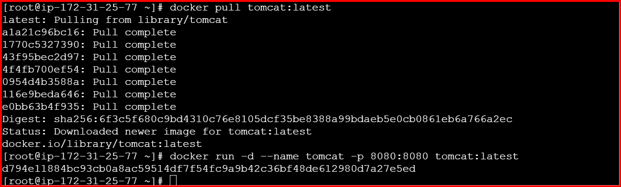

**wget** <https://tomcat.apache.org/tomcat-7.0-doc/appdev/sample/sample.war>

**docker cp sample.war tomcat:/usr/local/tomcat/webapps/**

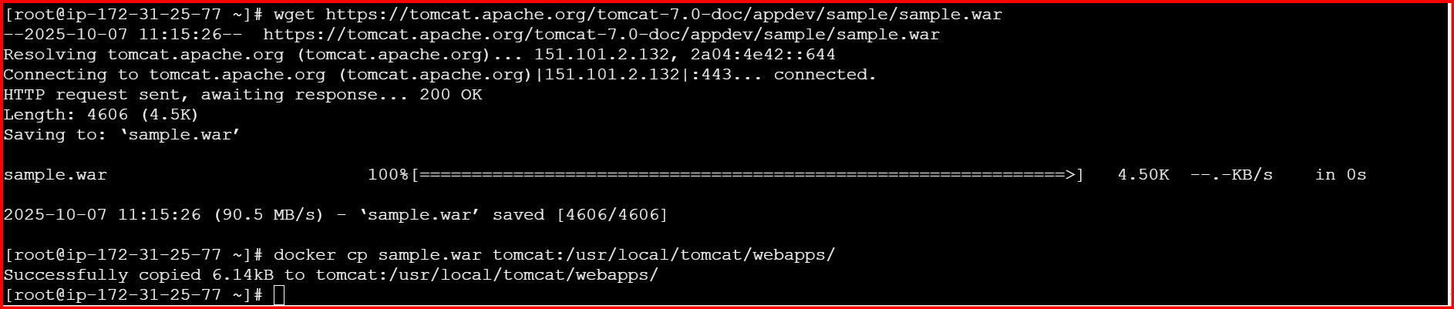

[**http://98.81.60.20:8080/sample/**](http://98.81.60.20:8080/sample/)

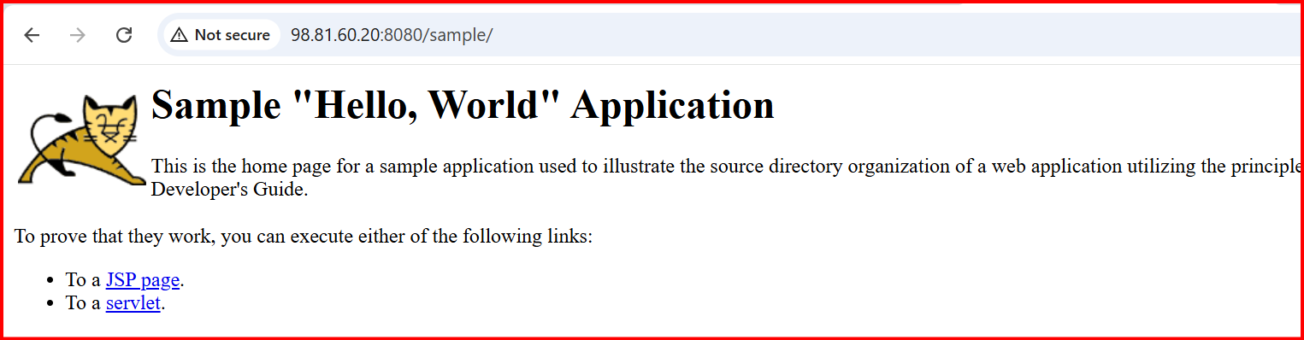

**2. Create volume and deploy tomcat container on port 8081.**

**docker volume create tomcat_data**

**docker run -d --name tomcat8081 -p 8081:8080 -v tomcat_data:/usr/local/tomcat/webapps tomcat:latest**

**docker cp sample.war tomcat8081:/usr/local/tomcat/webapps/**

**check the security groups**

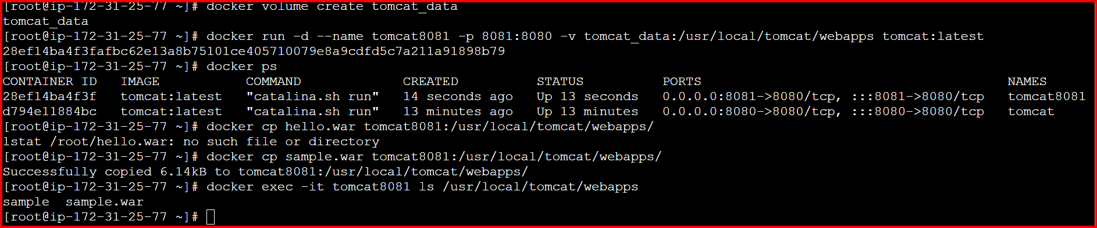

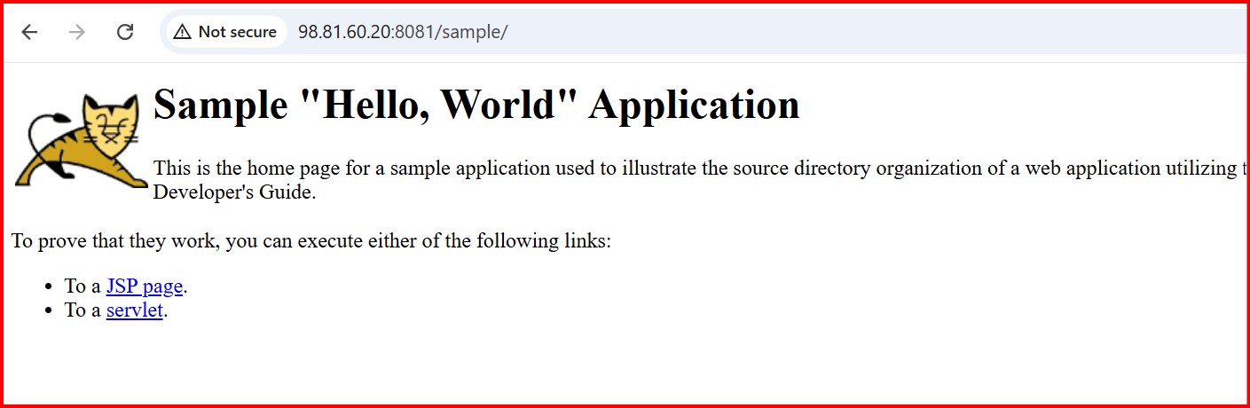

**3.Limit the nginx container to 500 MB.**

**docker run -d --name nginx_limit -p 8082:80 -m 500m nginx:latest**

**docker inspect nginx_limt | grep -I memory**

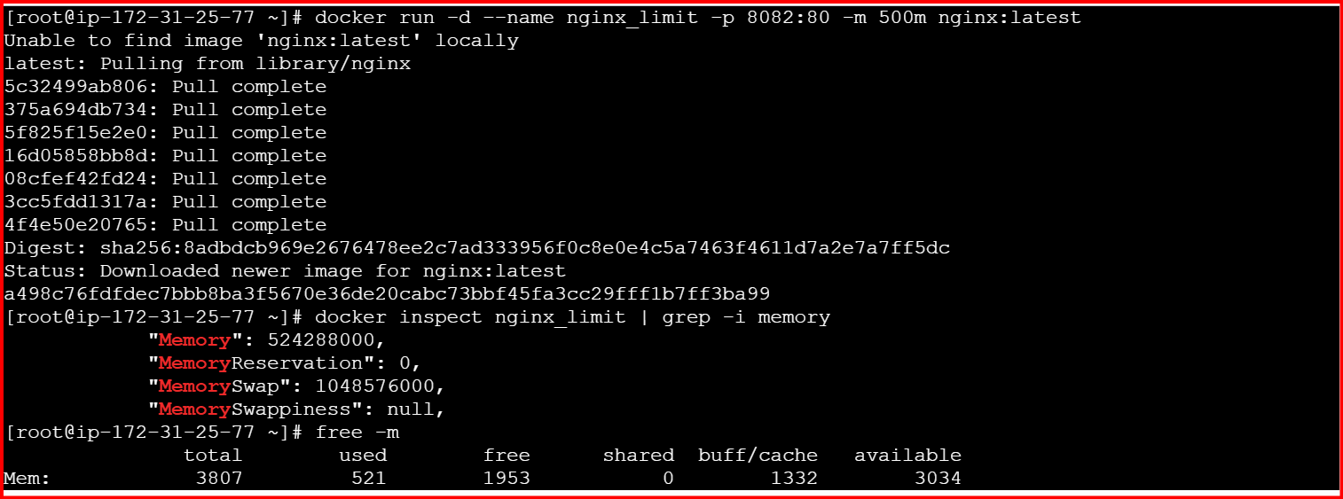

**4.Create a sample docker file using below instructions.**

* 1. **Base module as amazonlinux:latest**
  2. **Maintainer you name**
  3. **Install nginx**
  4. **COPY one index.html file to image**
  5. **Expose on port 80**
  6. **Command to start the nginx container**

**Vi docker**

**Vi index.html**

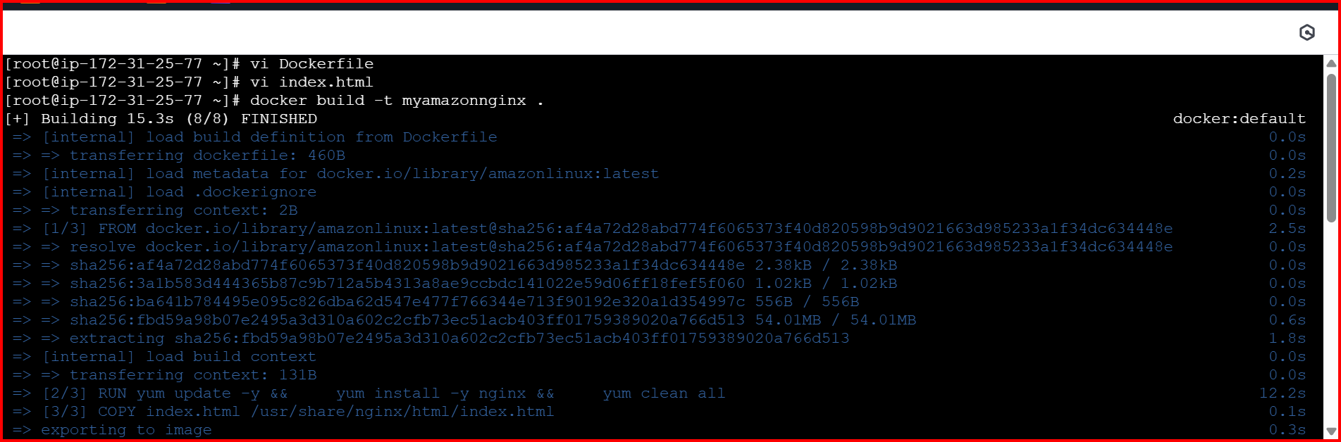

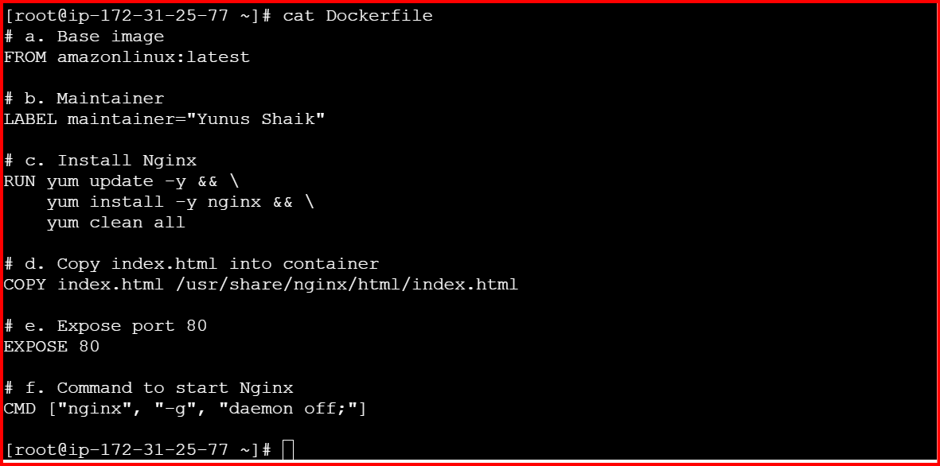

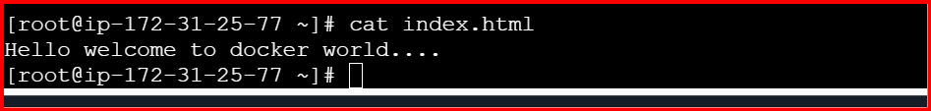

**docker run -d -p 8083:80 --name myamazonnginx myamazonnginx**



[**http://98.81.60.20:8083/**](http://98.81.60.20:8083/)

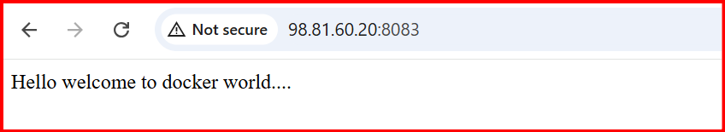

**5.Push image to Docker hub**

**First I have login to docker hub**

**Docker login**

**Username and password**

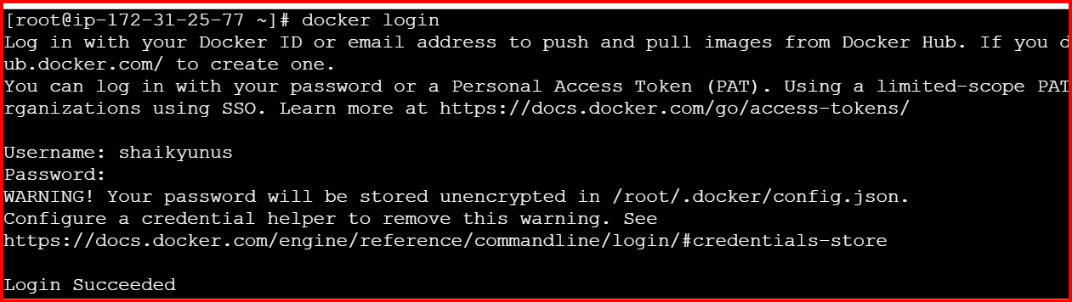

**docker tag nginx:latest shaikyunus/nginx:latest**

**docker tag nginx:latest shaikyunus/nginx:latest**

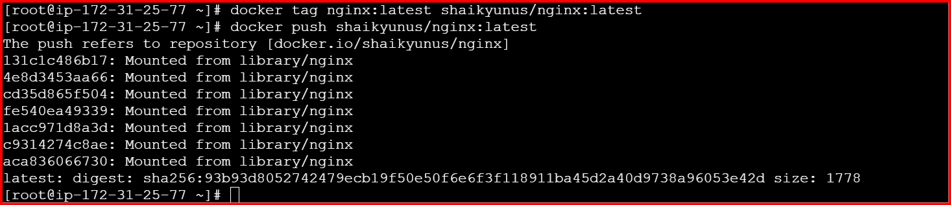

**Check in docker hub**

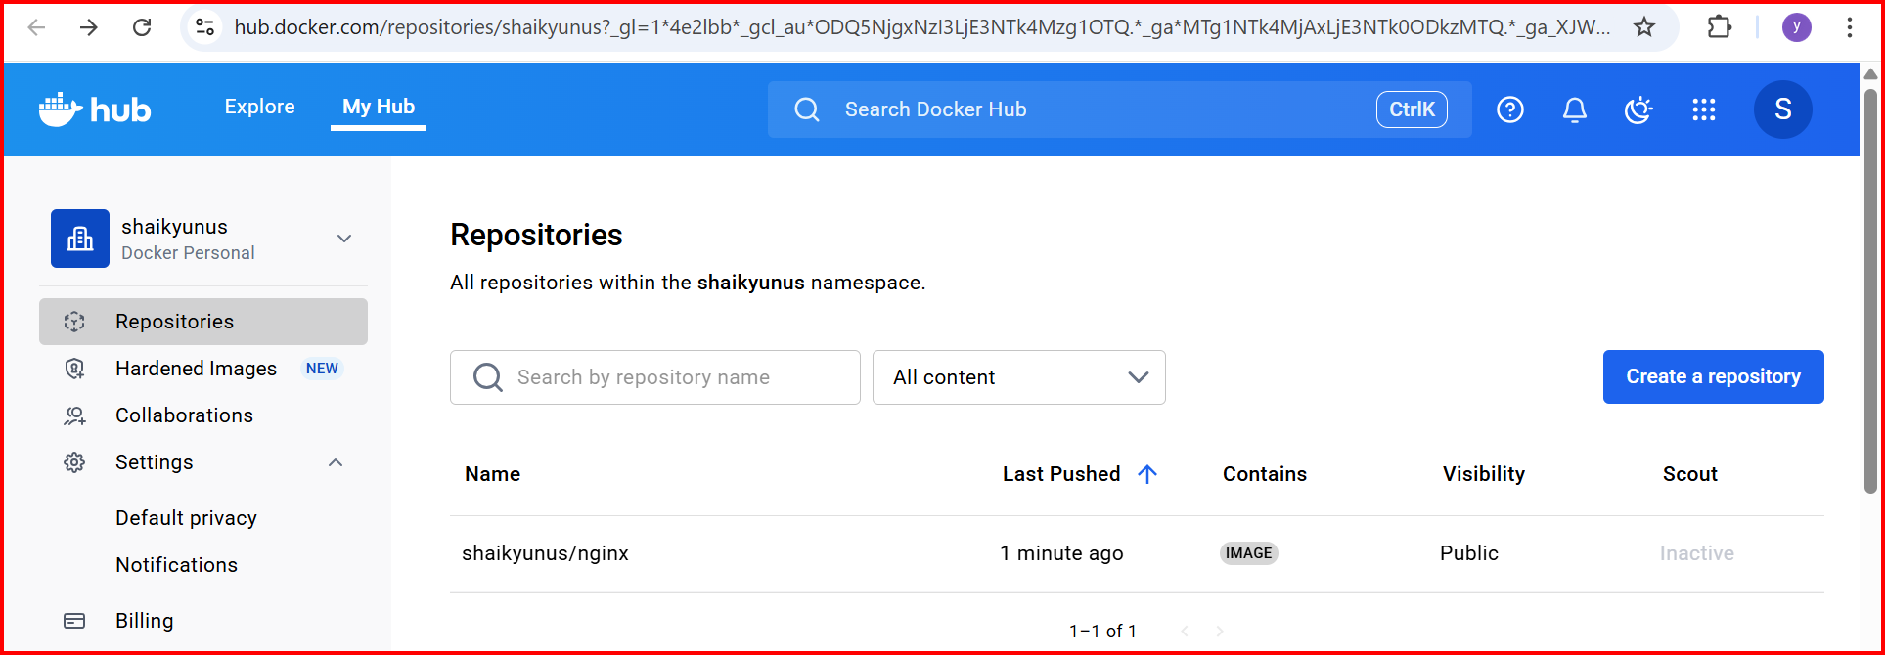

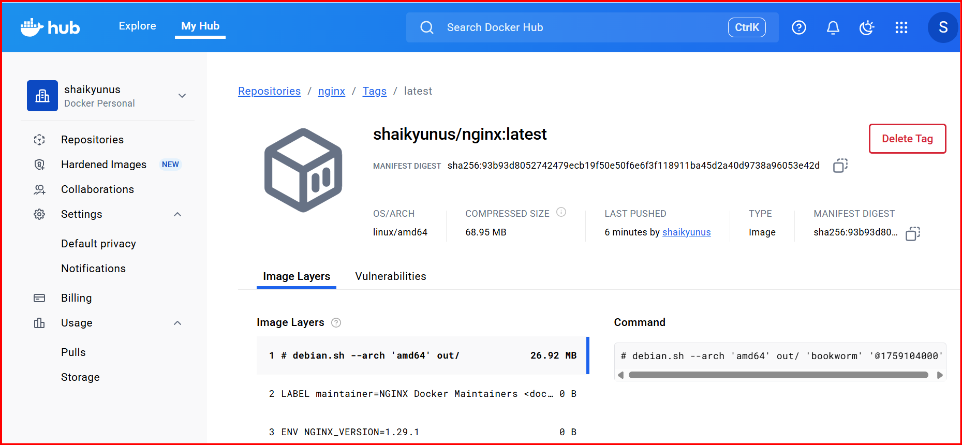

**6.push image to AWS ECR**

**Create a repository in AWS**

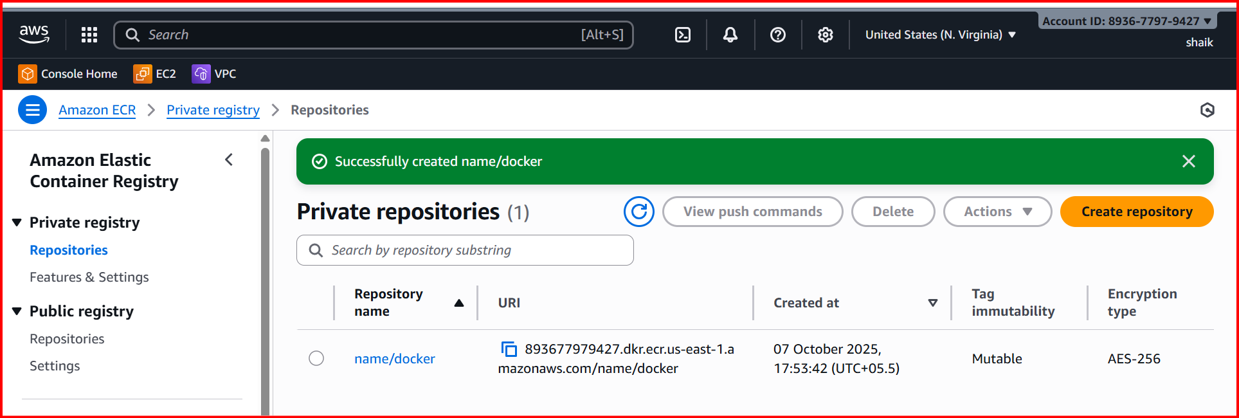

**AWS configure**

**1. Log in to ECR**

**aws ecr get-login-password --region us-east-1 | docker login --username AWS --password-stdin 893677979427.dkr.ecr.us-east-1.amazonaws.com**

**2. Tag your local image for ECR**

**docker tag myamazonnginx:latest 893677979427.dkr.ecr.us-east-1.amazonaws.com/name/docker:latest**

**3. Push the image**

**docker push 893677979427.dkr.ecr.us-east-1.amazonaws.com/name/docker:latest**

